Running scripts using docker – A quick guide

For an R-centric tutorial to using docker, I can really recommend https://ropenscilabs.github.io/r-docker-tutorial/ . Here, we don’t do anything particularly advanced, so it doesn’t take too long to be up and running with docker.

Install docker (available for windows 10, macOS, linux) and open it

On windows 10 home edition, make sure you follow instructions for installation on windows 10 home (e.g. making sure virtualisation is enabled), as this may be slightly different to other versions of windows.

To download the image from dockerhub, oppen terminal in mac, or command prompt in windows, and enter:

docker pull bignardig/verse_renv:aw6c5

WARNING it is a big file, so ensure you have 1GB of free storage.

To run the image, open terminal/command prompt again, and enter:

docker run -e PASSWORD=yourpassword -p 8787:8787 bignardig/verse_renv:aw6c5

You should change “yourpassword” to something unique for yourself. Keep it handy for later.

Lets check its running fine. Enter:
docker ps

you should see something that looks like this:

Now the container is running, we want to open it in a browser. The easiest way to do this is to open up dockerhub dashboard, and click “open in browser”.
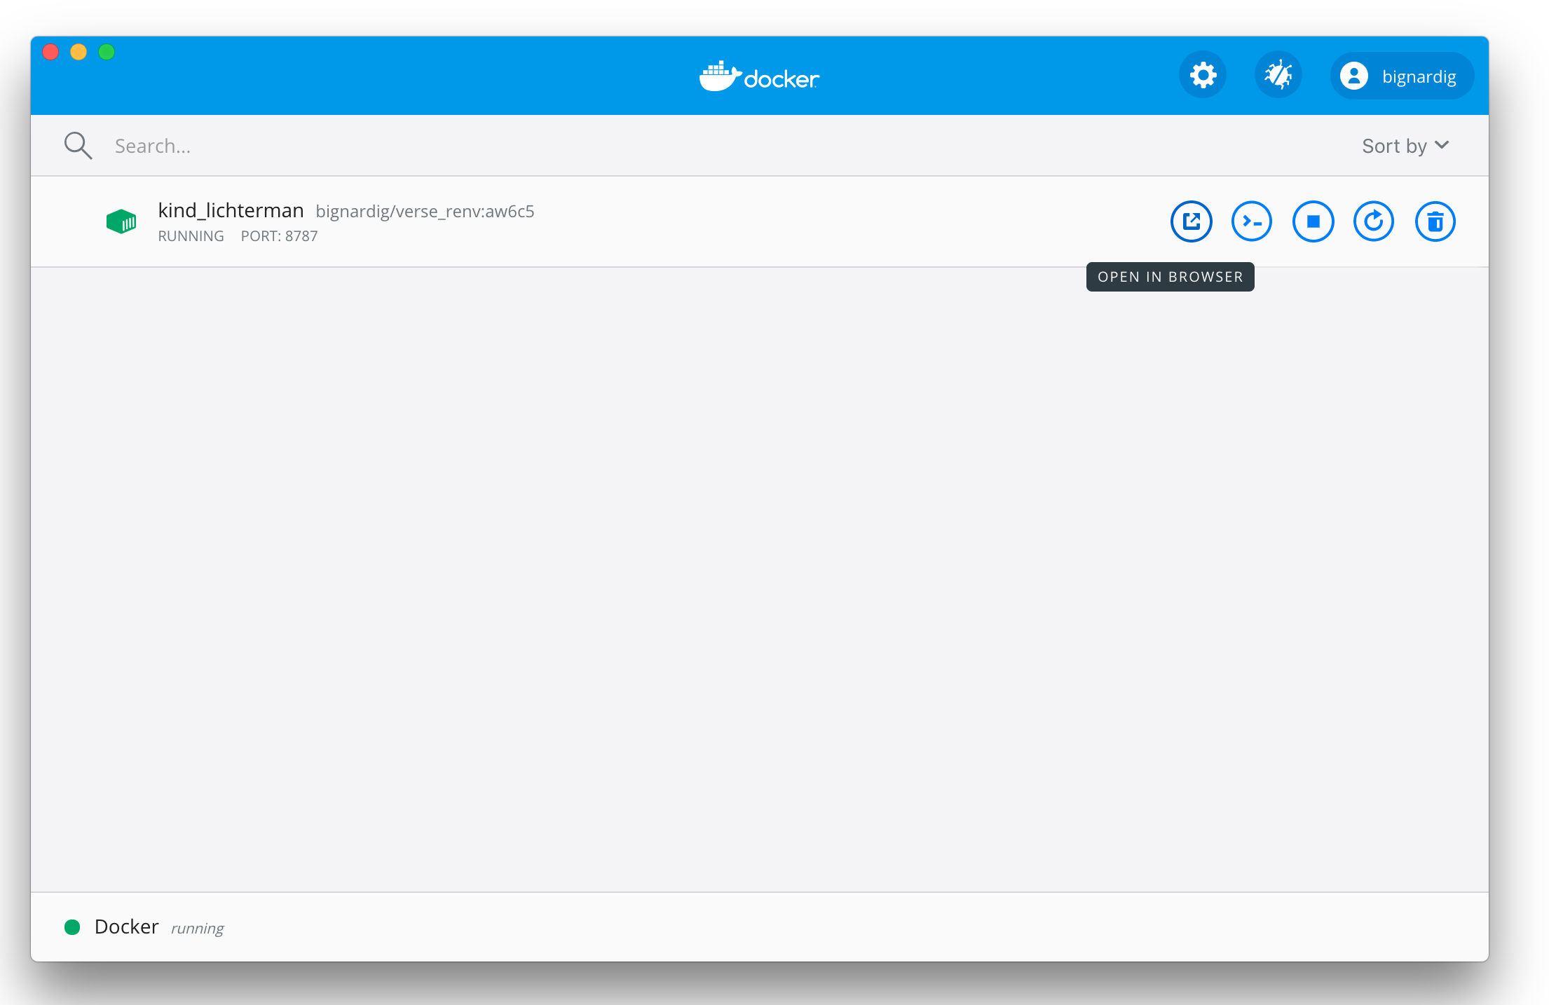
If that doesn’t work, try navigating to the number selected under ports (0.0.0.0:8787). Make sure the container says running here. When your done, you can stop and delete the container easily from the dashboard.

Download latest scripts and synthetic data from github

Navigate to:
https://github.com/giac01/BigDataSmallScreens

Under ‘code’ there will be an option to download the whole repository as a zip file. Do that and don’t unzip it.

Going back to the browser where we see our container running, enter rstudio as username and enter the password you created in step 2 ( ‘yourpasswordhere’), click sign in

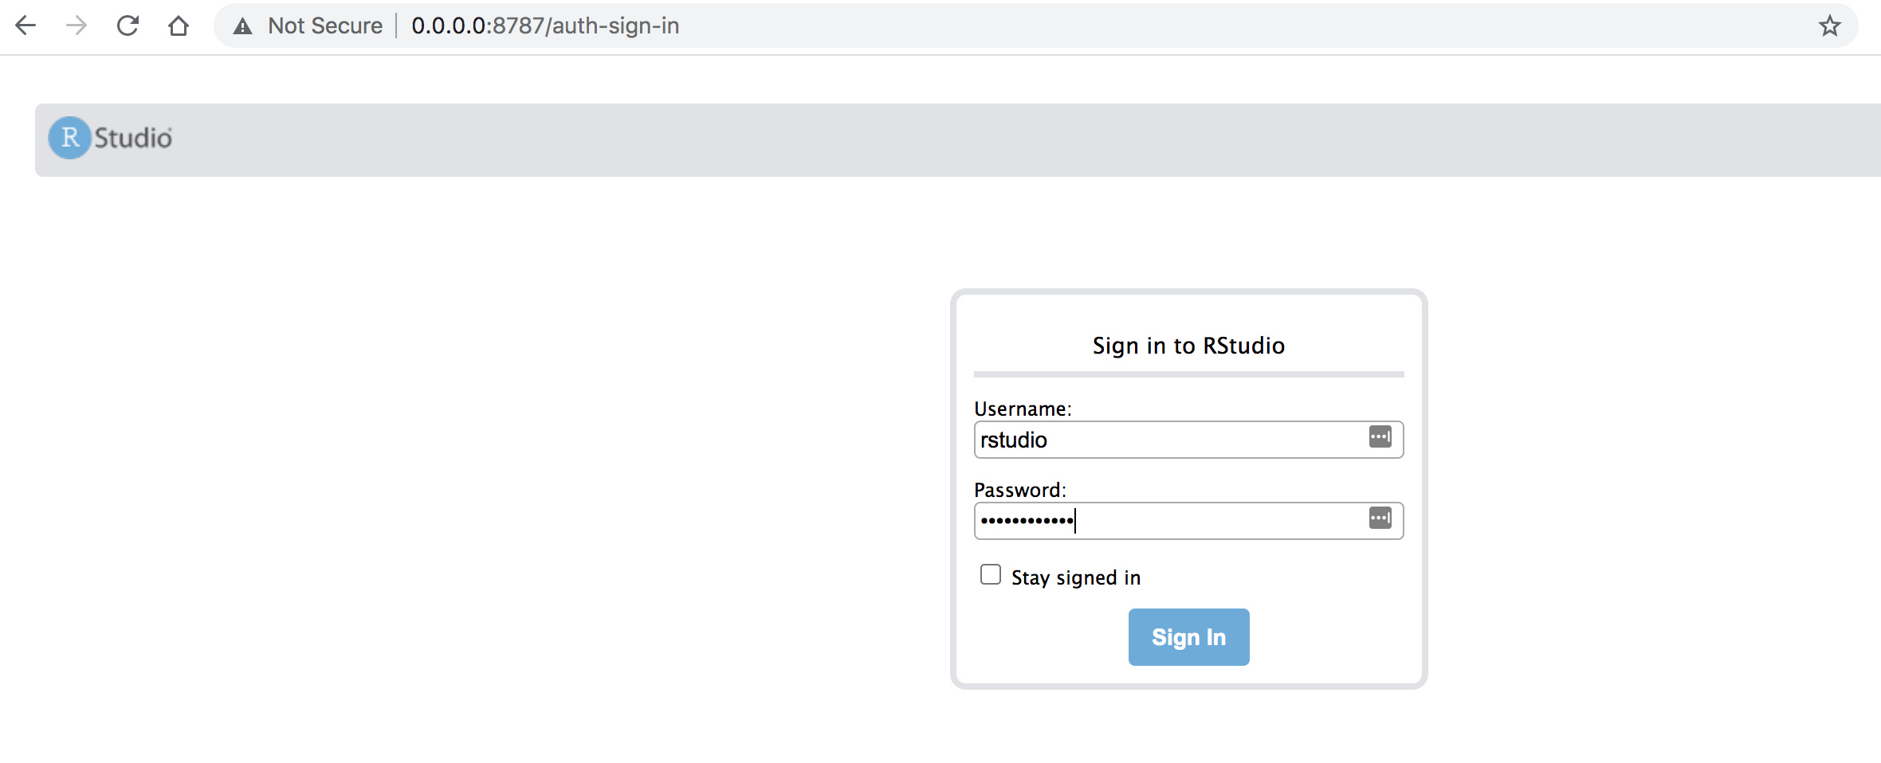

Now your logged in, navigate to ‘files’ on the bottom right, and click ‘upload’, and select the zip file (it should NOT be unzipped) we just downloaded from github.
Files should now look like this:
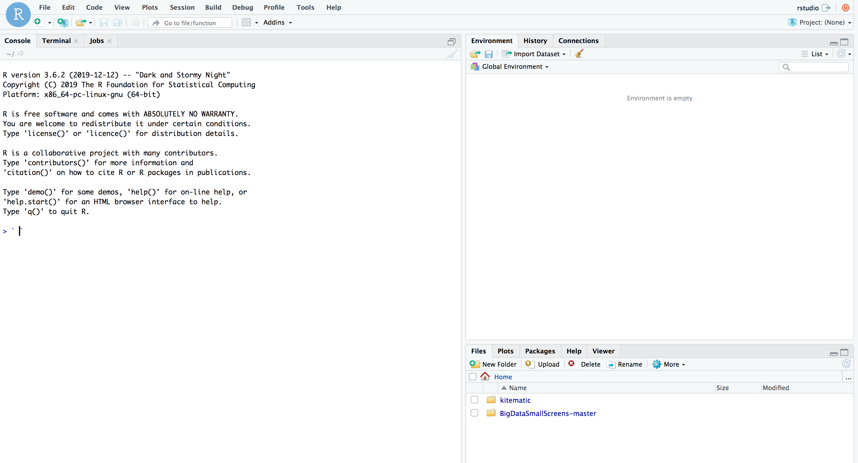

Required step: In the files panel, double click the BigData folder and navigate to “Analysis”, then click the “P1 – Psychometrics GITHUB.Rproj” file to open the Rproject. Scripts need to be run within the Rproject.

Now the scripts should run easily, with the required packages and r versions already working. Note that scripts P1S1 and P1S5 won’t run as the required raw data is not in the repository.

